9th April 2018

FIA WTCR Excitement in the Season Opener in Marrakech

*Hyundai-powered Italian veteran Tarquini wins twice to lead standings after inaugural event
*Vernay takes Race 2 as five brands fill top five places in dramatic contest

The new FIA World Touring Car Cup – WTCR, which boasts Japanese Tyre manufacturer YOKOHAMA as Official Tyre supplier, got off to an electrifying start on the streets of Marrakech with veteran Italian Gabriele Tarquini scoring an emphatic Race 3 victory to add to his Race 1 triumph from Saturday.

Driving a Hyunai i30 N TCR for BRC Racing Team, the Italian made the most of his Pole Position to win the final race of the weekend ahead of fellow world champions and Hyundai drivers Yvan Muller and Thed Björk.

Four-time World Touring Car title winner Muller qualified alongside Tarquini on the front row, but made a relatively slow start and moved left to block Norbert Michelisz’s BRC Racing Team entry. That allowed Björk to jump both for second place into Turn 1. But the Swede Björk lost what appeared to be a certain runner-up spot when he accidentally knocked the power switch, miraculously just one spot to Muller.

Earlier in the day, the reverse-grid Race 2 was won by Jean-Karl Vernay in his Audi Sport Leopard Lukoil Team Audi RS 3 LMS. The Frenchman headed local hero Mehdi Bennani, who claimed a hugely popular podium in his Sébastien Loeb Racing Volkswagen Golf GTI TCR. Pepe Oriola took third having lined up on the reverse-grid pole. Fourth for ALL-INKL.COM Münnich Motorsport driver Yann Ehrlacher and fifth for Björk meant five different car brands filled the top five places.

Rob Huff took third in the opening counter, which was broadcast live on Facebook and OSCARO.com in selected territories.

“The car is fantastic, the pace was great,” said an ecstatic Tarquini. “It was not easy after the crash I had in Race 2, but the guys worked hard and the car was perfect. Incredible. I am over the moon and I hope the dream continues.”

Vernay, the weekend’s other winner, said: “It’s a great weekend, we were not expecting that kind of result before we come here. But we got lots of points and we finished all the races with my beautiful Audi in one piece.” For his part a spokesman for YOKOHAMA Europe expressed satisfaction with the first race weekend and the excitement brought about in the new series. “We are delighted to continue being an essential part of Touring car racing and especially this new race series which promises and delivers thrills and spills.
The next race weekend will be held in Hungary at the end of this month – 28th & 29th at the legendary Hungaroring.

Current Driver Standings
- Gabrielle Tarquini 62pts
- Thed Bjork 51pts
- Jean-Karl Vernay 41pts

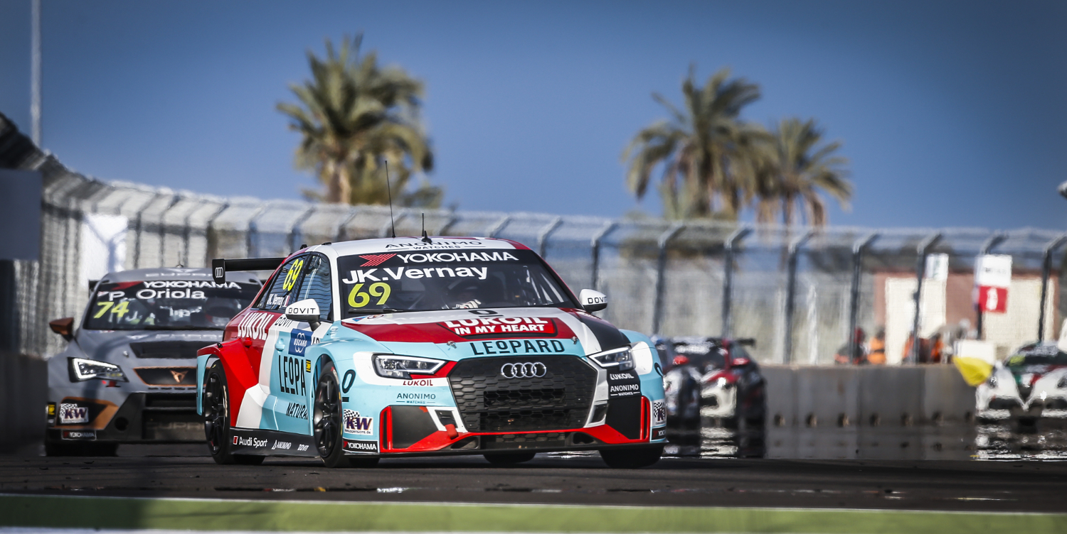
Jean Karl Vernay

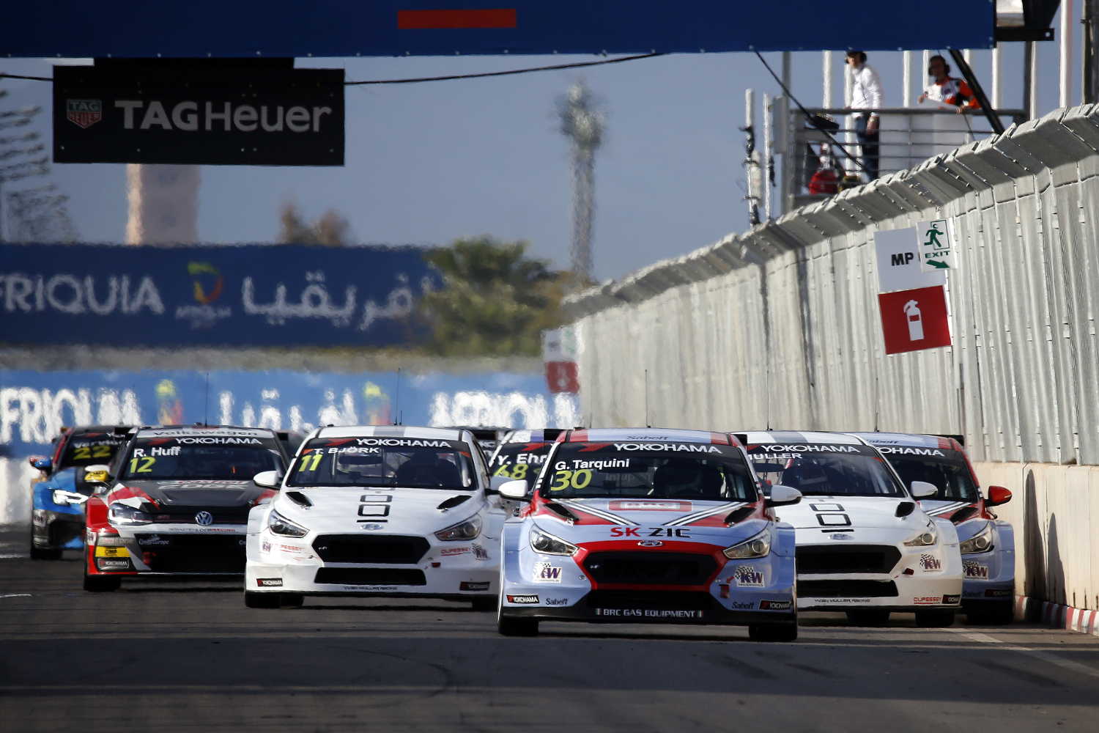
WTCR Gabriele Tarquini

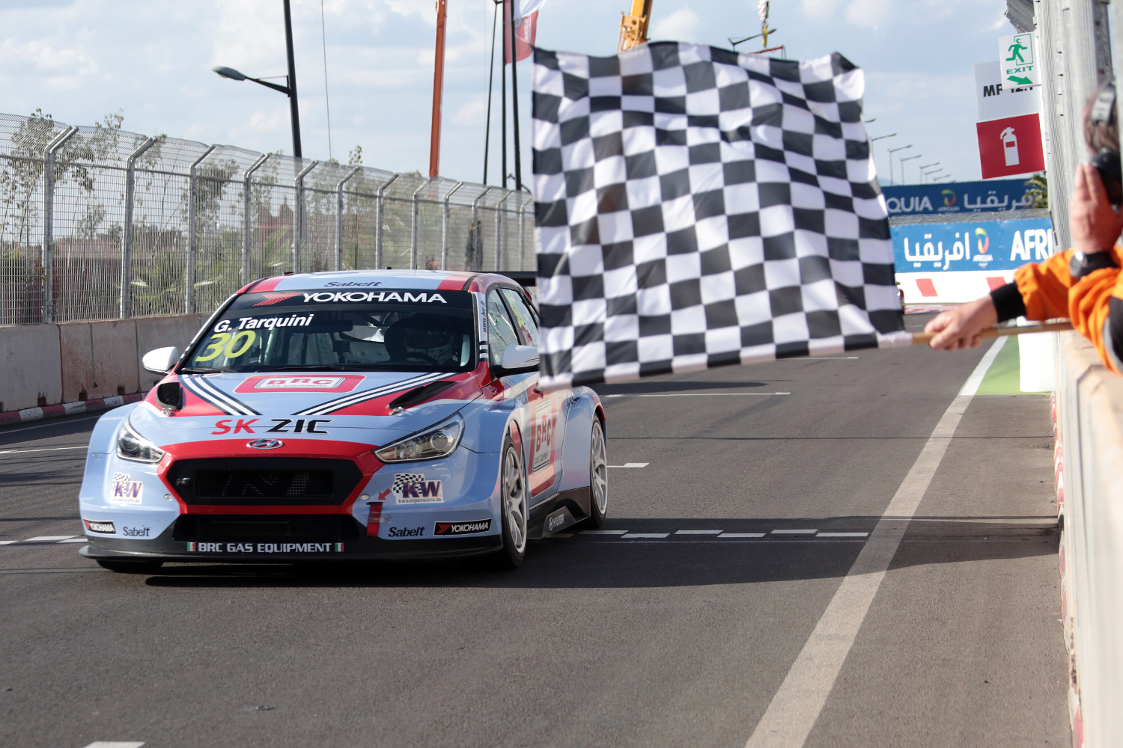
WTCR Gabriele Tarquini

